- Booking of Appointments
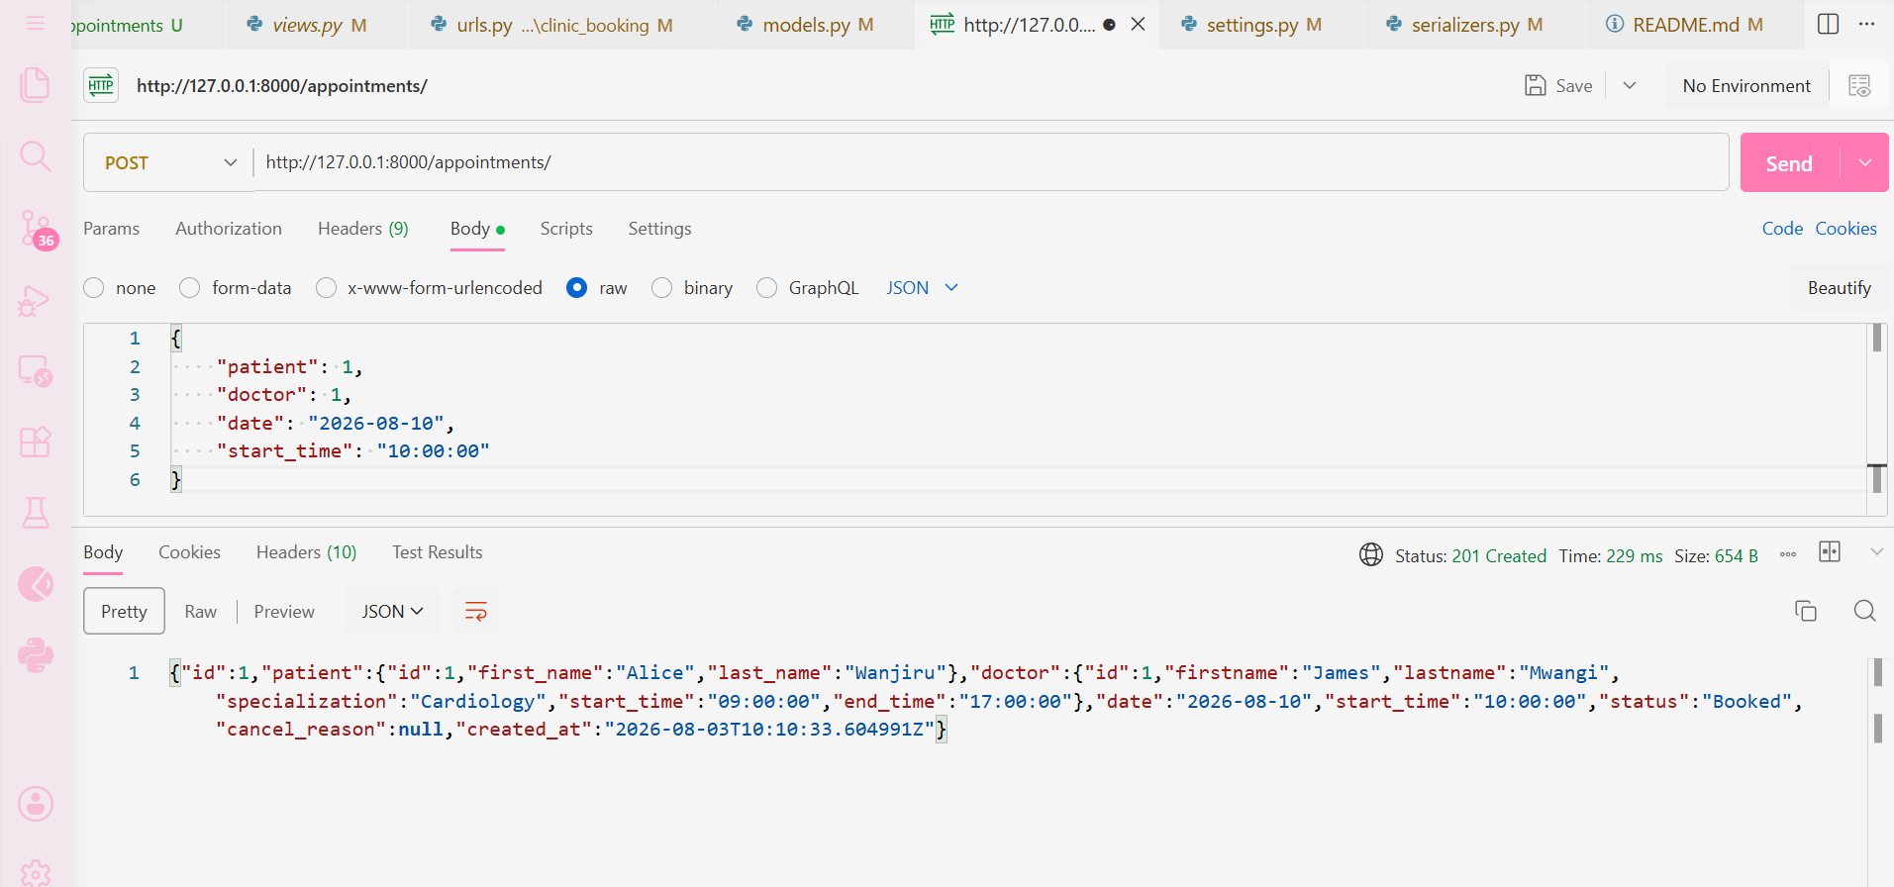

- Return Doctor Availability-10AM Booked above
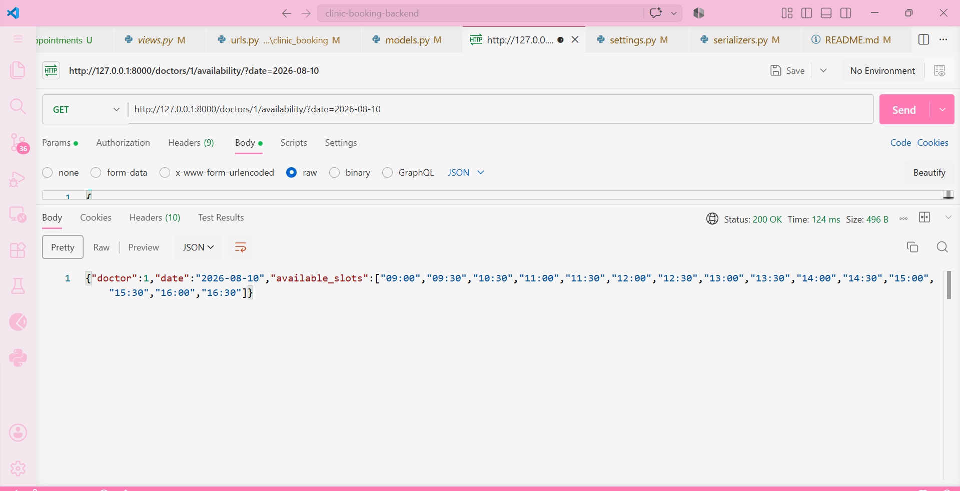

- PATCH /appointments/{id}/cancel
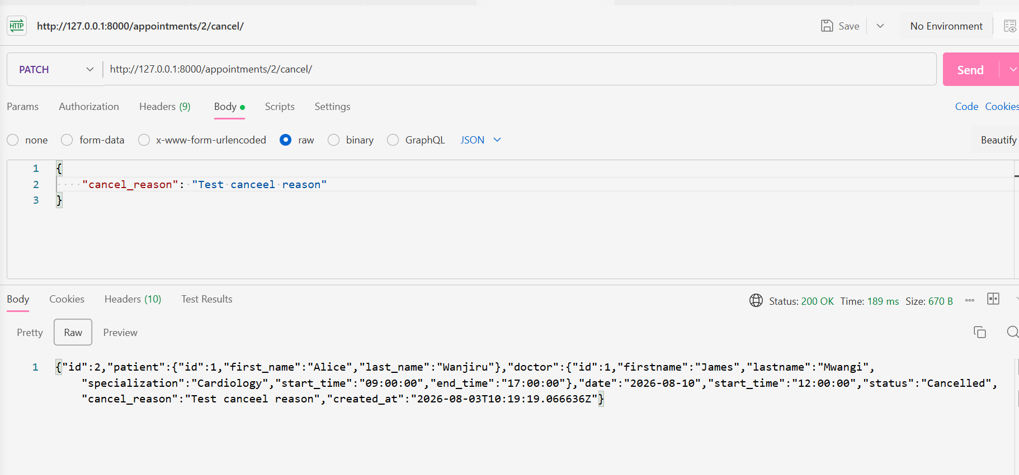
- 12PM back to being available after cancellation

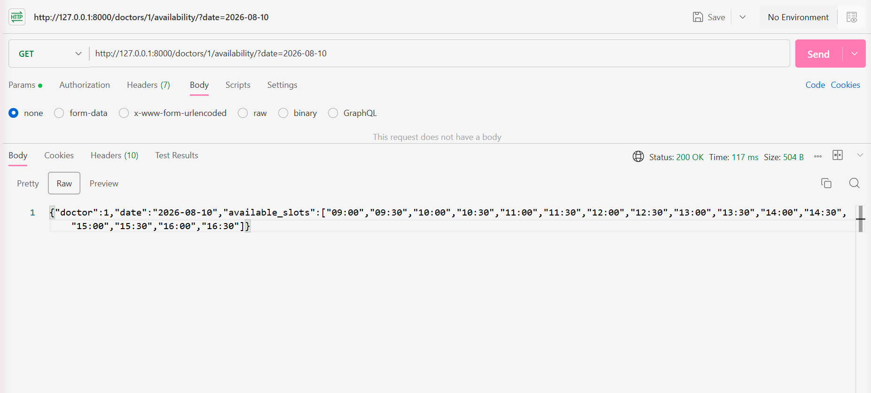

- PATCH /appointments/{id}/reschedule-appointment 3 reschudeled to 4.30pm
